VIETNAM INTERNATIONAL UNIVERSITY – HO CHI MINH CITY

INTERNATIONAL UNIVERSITY



WEB APPLICATION DEVELOPMENT PROJECT

SHOES SHOPPING ONLINE

**Members of Group:**

Lê Thành Đại Dương_ITITUN14002

Vương Khắc Duy_ITITUN14010

Ninh Thế Lâm_ ITITUN14007

GitHub Link: <https://github.com/tieuduong241096/2017S2-WEB_LAB->

# Introduction

**1.1 About us**

This section will bring you the background information of our web product. The abstract description about the product that our team will design. Furthermore, the constraints which will affect our project is also included in this part.

|  |  |
| --- | --- |
| **Information** | **Details** |
| Team members | 3 members: Dương , Lâm , Duy |
| Business | Web Application Developement Project: **E-Commerce Web** |
| Customer | International University – Viet Nam National University Ho Chi Minh City |
| Contact | Office: 6th floor, A Block, International University, Thu Duc, HCMC.  Email:  Tel: |

* 1. **Overview**

**Project Title** – **E-Commerce Web**

**Objective**

* To develop a web application that allows a registered customer to purchase a variety of shoes by a list of registered shops.
* To provide an easy to use Interface.

**Basic Requirements**

* ***Customer***
* Secured registering and managing their profiles.
* Easy navigation through pages.
* Secured Payment gateway.
* ***Shop owner***
* Secured registering and managing their profiles.
* Add, delete or modify the already posted products.
* ***Administrator***
* Authority to approve and reject requests for new items.
* Can control customers and shop owners actions.
  1. **Project Scope**
* *Scope – In*
* Websites for desktop, which is compatible with IE, Mozilla, Chrome etc.
* Purchase products available in the website.
* *Scope – Out*
* Payment Gateways to be linked through APIs.
* Not compatible for mobile users.
* *Users*
* Customers
* Shop owners
* Administrators

# Use Case Diagram

## USE CASE 1:

**Name**: Search Product

**Identifier** UC6

**Inputs**: Input desired product name

**Output**: Show all products that have the letters that user typed in

**Basic Course**

|  |  |
| --- | --- |
| ACTOR(User) | SYSTEM |
| 1.Input Product name | Display the all of products |
| 2.Click on The product | Display the detail of product |

**Precondition:** None

**Post condition:** None

**User Story:** As a customer, I want to search the products.

## USE CASE 2:

**Name**: Purchase History

**Identifier**: UC2

**Inputs**: User ID

**Output**: Information of purchase history

**Basic Course**

|  |  |
| --- | --- |
| ACTOR(User) | SYSTEM |
| 1. Login |  |
| 1. Input | User ID |
| 1. Submit | Show the purchase history |

**Precondition:** Users have to log in with their own account.

**Post condition:** None.

**User story:** Customers can check the purchase history in the future.

## USE CASE 3:

**Name**: Recommend

**Identifier** UC3

**Inputs**:

**Output**: The list of recommend product based on mutual friends interesteds

**Basic Course**

|  |  |
| --- | --- |
| ACTOR(User) | SYSTEM |
| 1. Login |  |
| 1. Input | * The name of products into the search products. * Click recommend products button. |
| 1. Submit | * The list of recommend products. |

**Precondition:** None

**Post condition:** None

**User story:** The list of recommend products.

# System Architecture

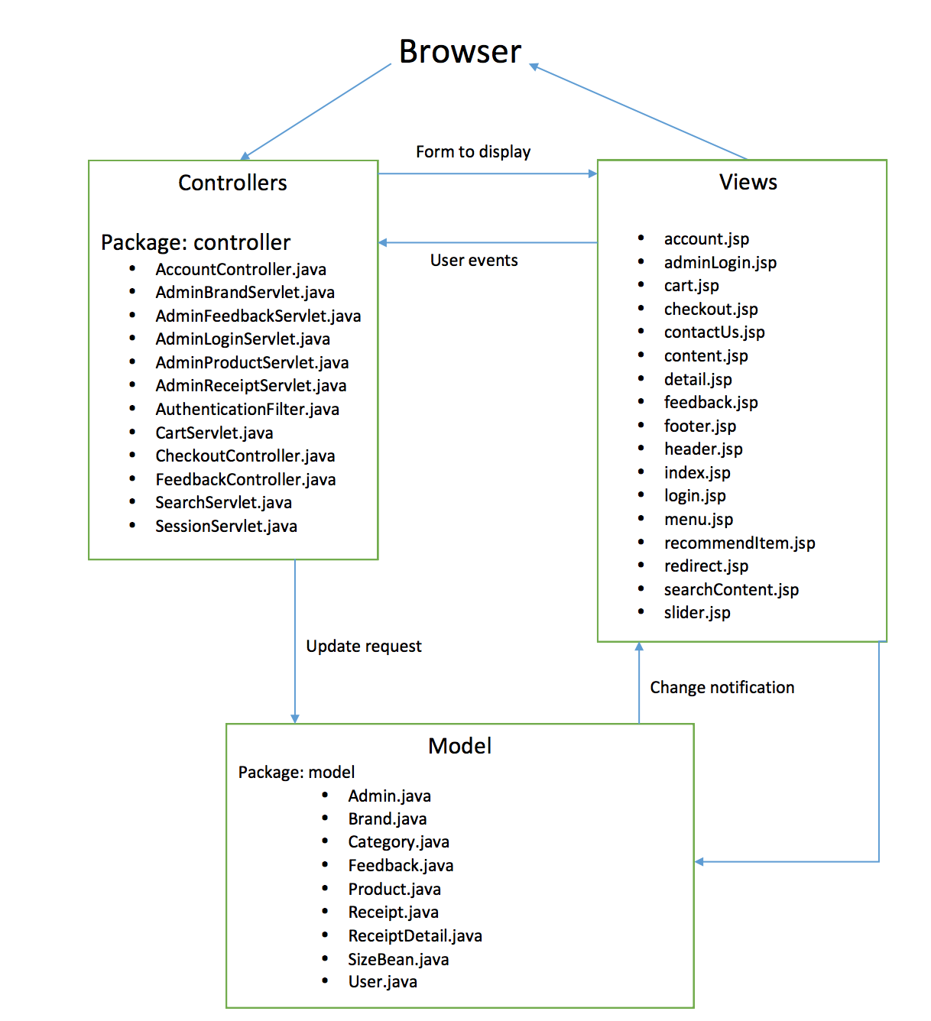

# Database Design

Entity Diagrams.

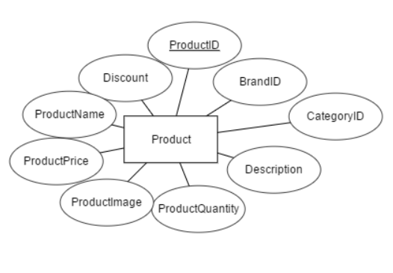 **Product**

**Brand**

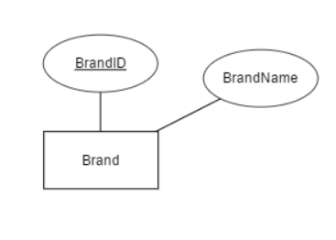

**Category**

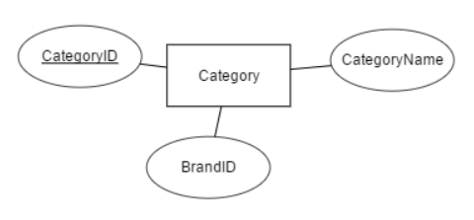

**Receipt**

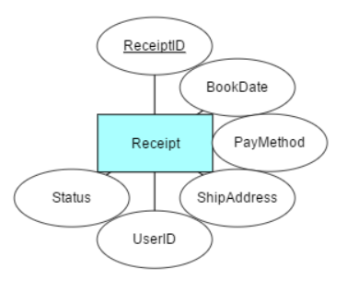

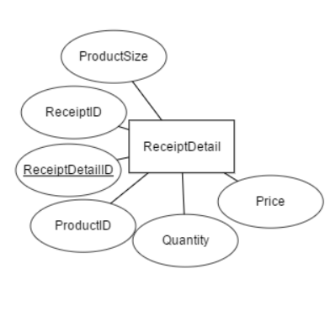**Receipt Detail**

**User**

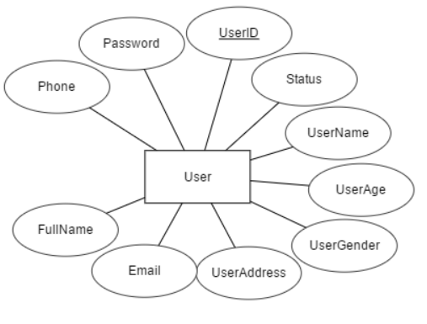

**Feedback**

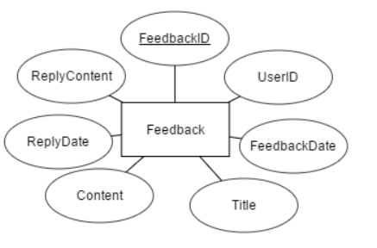

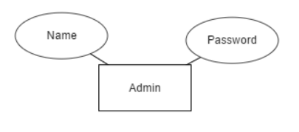**Admin**

Tables Design

|  |  |  |  |  |  |
| --- | --- | --- | --- | --- | --- |
|  | **Table** | **No of Attribute** | **Primary Key** | **Related Table** | **Foreign Key** |
| 1 | Product | 9 | ProductID | Brand, Category, ReceiptDetail | BrandID, CategoryID |
| 2 | Brand | 2 | BrandID | Product, Category |  |
| 3 | Category | 3 | CategoryID | Product, Brand | BrandID |
| 4 | Receipt | 6 | ReceiptID | User, ReceiptDetail | UserID |
| 5 | ReceiptDetail | 6 | ReceiptDetailID | Product, Receipt | ReceiptID,  ProductID |
| 6 | User | 10 | UserID | Feedback, Receipt |  |
| 7 | Feedback | 7 | FeedbackID | User | UserID |
| 8 | Admin | 2 | Name |  |  |

Entity Description

**PRODUCT**

|  |  |  |  |  |  |  |  |
| --- | --- | --- | --- | --- | --- | --- | --- |
| Field name | Type (size) | Identity | NULL | PK | FK | References | Description |
| ProductID | int | yes | no | PK |  |  | Product identity number |
| ProductName | varchar(255) |  | no |  |  |  | Product Name |
| ProductPrice | double |  | no |  |  |  | Product’s Price |
| ProductImage | varchar(255) |  | no |  |  |  | Product’sImage |
| ProductQuantity | int |  | no |  |  |  | Product’s Quantity |
| Description | varchar(255) |  |  |  |  |  | Product’s Description |
| Discount | double |  |  |  |  |  | Product’s Discount |
| BrandID | int |  | no |  | FK | Brand(BrandID) | One brand has many products |
| CategoryID | int |  | no |  | FK | Category(CategoryID) | One category has many products |

**BRAND**

|  |  |  |  |  |  |  |  |
| --- | --- | --- | --- | --- | --- | --- | --- |
| Field name | Type (size) | Identity | NULL | PK | FK | References | Description |
| BrandID | int | yes | no | PK |  |  | Brand ID |
| BrandName | varchar(30) |  | no |  |  |  | Brand Name |

**CATEGORY**

|  |  |  |  |  |  |  |  |
| --- | --- | --- | --- | --- | --- | --- | --- |
| Field name | Type (size) | Identity | NULL | PK | FK | References | Description |
| CategoryID | int | yes | no | PK |  |  | Category ID |
| CategoryName | varchar(255) |  | no |  |  |  | Category Name |
| BrandID | int |  |  |  | FK | Brand(BrandID) | One brand has many Category |

**USER**

|  |  |  |  |  |  |  |  |
| --- | --- | --- | --- | --- | --- | --- | --- |
| Field name | Type (size) | Identity | NULL | PK | FK | References | Description |
| UserID | int | yes | no | PK |  |  | User identity number |
| UserName | varchar(30) |  | no |  |  |  | User name to login |
| Password | varchar(30) |  | no |  |  |  | User’s password to login |
| UserAge | int |  | no |  |  |  | User age |
| UserGender | bit |  | no |  |  |  | bit 1: Male; bit 0: Female |
| UserAddress | varchar(255) |  | no |  |  |  | User’s Address |
| Email | varchar(255) |  | no |  |  |  | User’s Email |
| FullName | varchar(255) |  | no |  |  |  | User’s FullName |
| Phone | varchar(15) |  | no |  |  |  | User’s Phone |
| Status | bit |  |  |  |  |  | bit1: active; bit 0: inactive |

**RECEIPT**

|  |  |  |  |  |  |  |  |
| --- | --- | --- | --- | --- | --- | --- | --- |
| Field name | Type (size) | Identity | NULL | PK | FK | References | Description |
| ReceiptID | int | yes | no | PK |  |  | Receipt identity number |
| BookDate | datetime |  | no |  |  |  | The date user book product |
| PayMode | varchar(50) |  | no |  |  |  | User Paying Method: Pay after shipping or Credit Card |
| ShipAddress | varchar(50) |  | no |  |  |  | User prefered shipping address |
| UserID | int |  | no |  | FK | User(UserID) | One user has many receipts |
| status | bit |  | no |  |  |  | Already shipped to users or not:  1: shipped; 0: not shipped |

**RECEIPT DETAIL**

|  |  |  |  |  |  |  |  |
| --- | --- | --- | --- | --- | --- | --- | --- |
| Field name | Type (size) | Identity | NULL | PK | FK | References | Description |
| ReceiptDetailID | int | yes | no | PK |  |  | Receipt Detail identity number |
| Quantity | int |  | no |  |  |  | User’s prefered quantity |
| price | double |  | no |  |  |  | Total Price (productPrice * quantity) |
| ReceiptID | int |  | no |  | FK | Receipt(ReceiptID | one receipt has many receipt detail |
| ProductID | int |  | no |  | FK | Product(ProductID) | One receipt detail has many product |
| size | double |  | no |  |  |  | User’s prefered shoe size |

**FEEDBACK**

|  |  |  |  |  |  |  |  |
| --- | --- | --- | --- | --- | --- | --- | --- |
| Field name | Type (size) | Identity | NULL | PK | FK | References | Description |
| FeedbackID | int | yes | no | PK |  |  | Feedback Detail identity number |
| UserID | int |  | no |  | FK | User(UserID) | one user has many feedback |
| FeedbackDate | datetime |  | no |  |  |  | User’s FeedbackTime |
| Title | varchar(50) |  | no |  |  |  | Feedback Title |
| Content | varchar(255) |  | no |  |  |  | Feedback Content |
| ReplyDate | datetime |  |  |  |  |  | Admin’s reply date |
| ReplyContent | varchar(255) |  |  |  |  |  | Admin’s reply content |

**ADMIN**

|  |  |  |  |  |  |  |  |
| --- | --- | --- | --- | --- | --- | --- | --- |
| Field name | Type (size) | Identity | NULL | PK | FK | References | Description |
| Name | varchar(255) | yes | no | PK |  |  | Admin name |
| Password | varchar(255) |  | no |  |  |  | Admin Password |

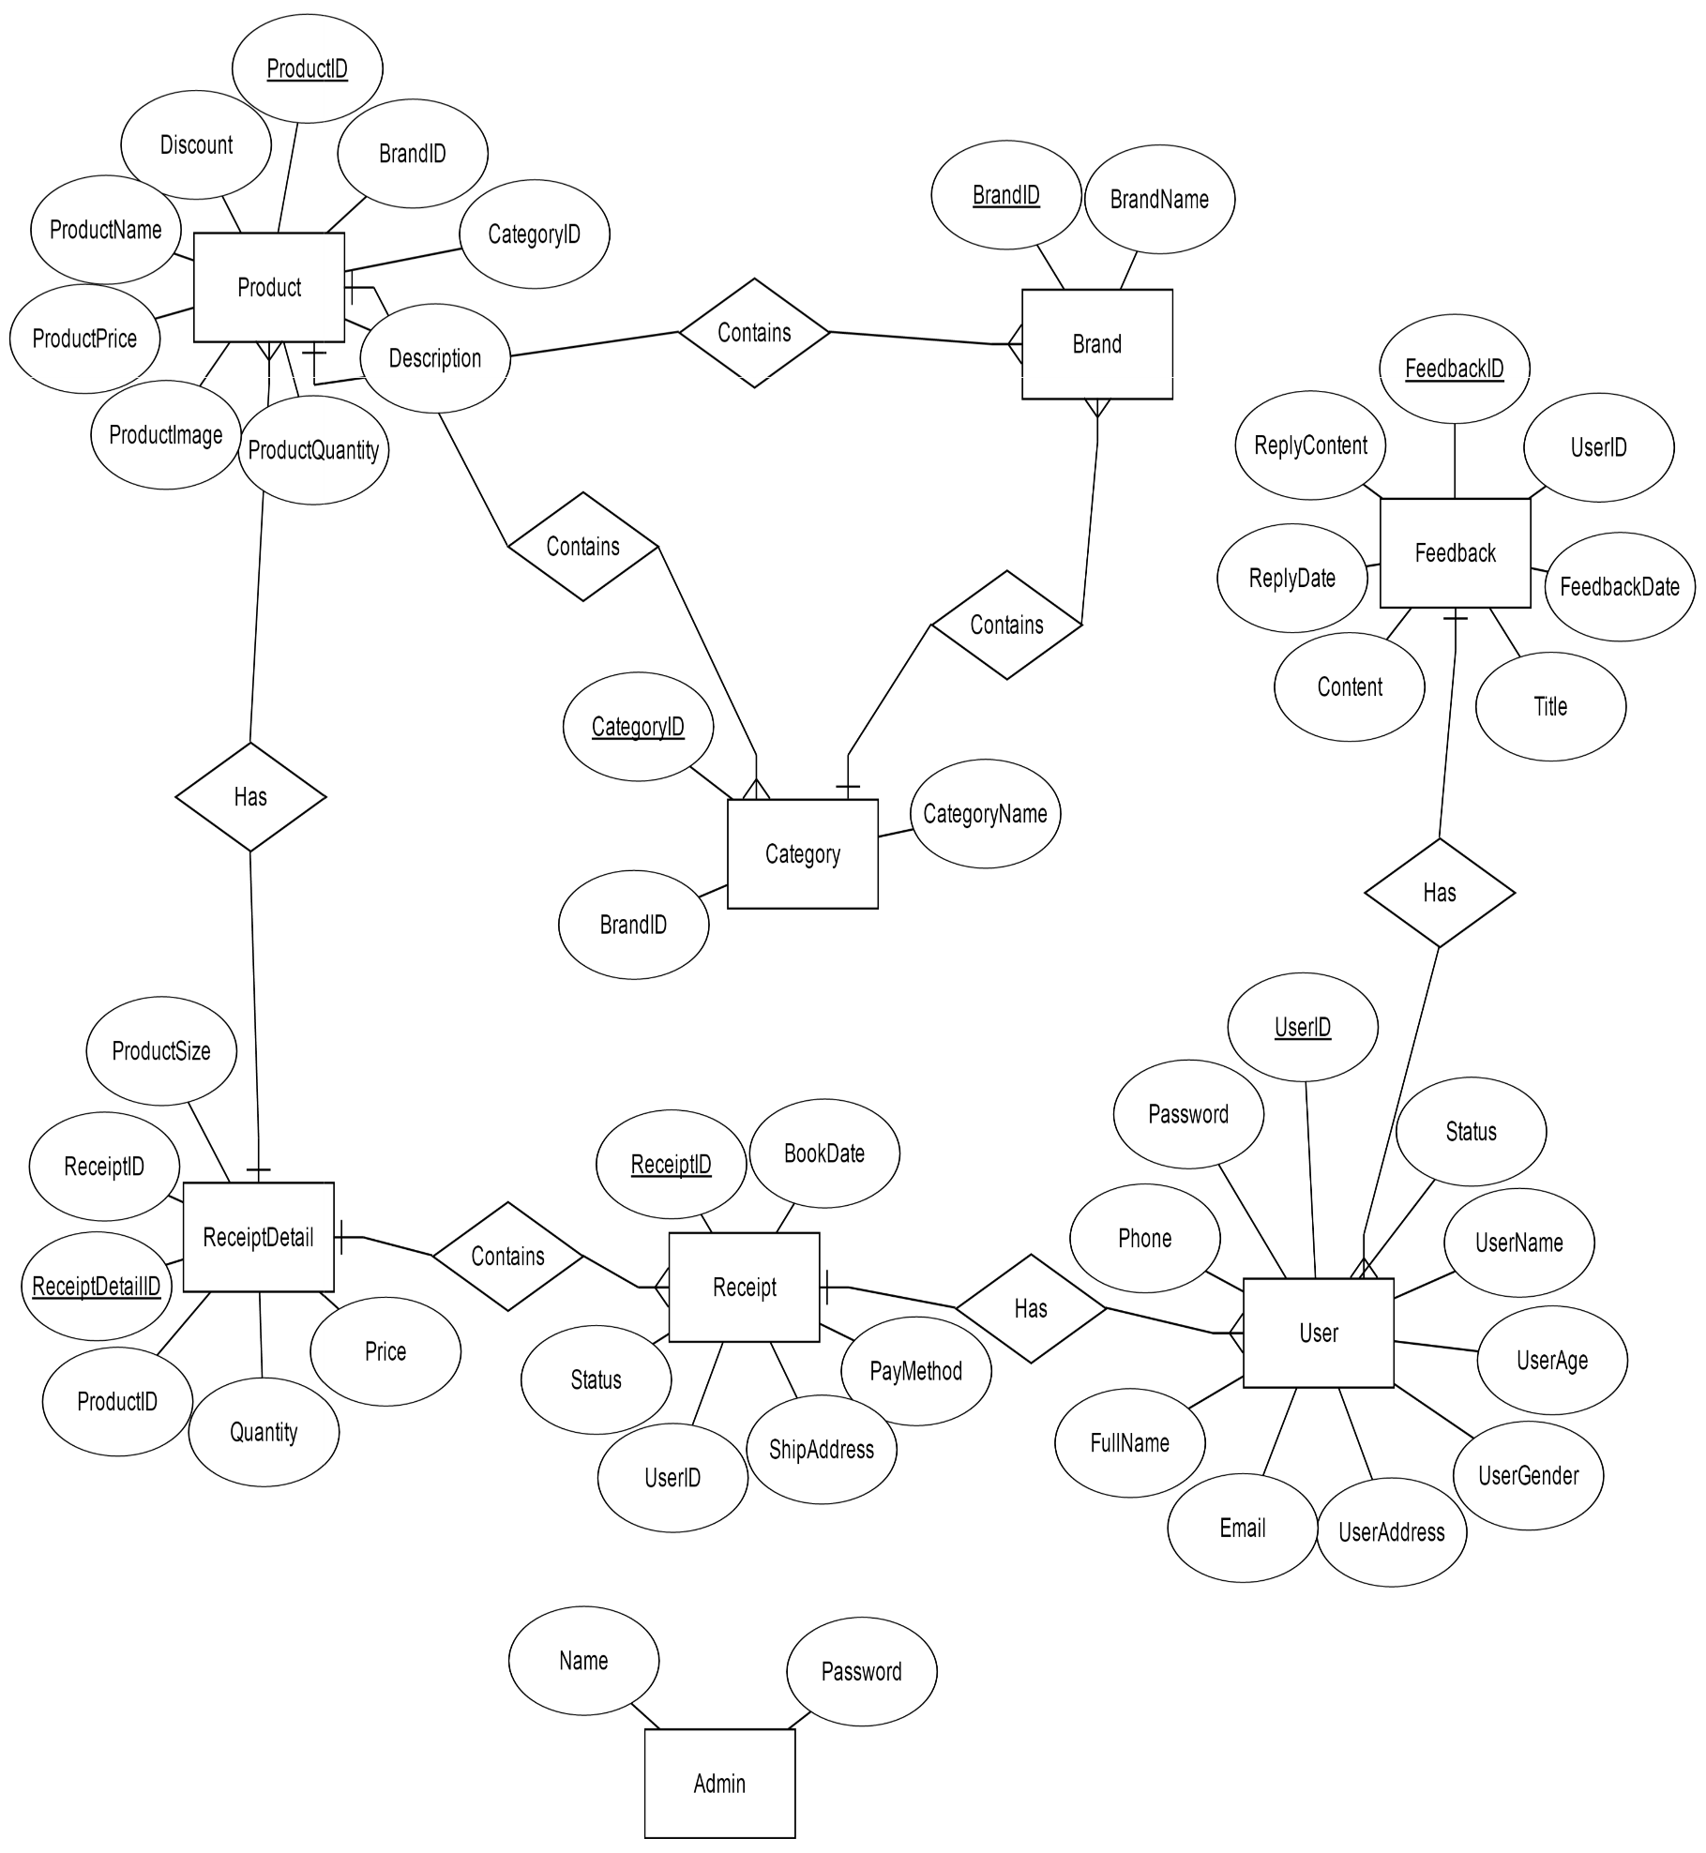ERD